School Summer Adventure Passport
Social Media
🎒✨ Is your child starting school this September?
Get ready for a summer full of fun, learning, and adventure with the Summer Learning Passport! 🌞📘
This special booklet is packed with exciting activities and challenges designed to spark curiosity and build confidence in little learners. From developing independence to making friends, exploring stories, and getting school-ready — there’s something for every child!
🌟 What’s inside?
✅ Creative arts & crafts
✅ Treasure hunts & bear hunts
✅ Sports days & Tiny Rangers
✅ Toilet training & virtual family workshops
✅ Storytelling, LEGO fun & so much more!
We’re proud to be working with amazing partners like the Art Gallery, Voluntary Community Sector, Library, NHS Health Visitors, Leisure Centres, Arts Connect, and the National Literacy Trust to bring these experiences to life.
📩 Don’t miss out!
Sign up to our newsletter for updates:
👉 https://www.walsallfamilyhubs.co.uk/family-hubs/newsletter/sign-our-mailing-list#main
Explore the passport here:
👉 https://www.walsallfamilyhubs.co.uk/2-4/summer-adventure-passport#main
Let’s make this summer one to remember! 🌈🎉
#Walsallfamilyhubs #WalsallSummerPassport
@Walsallfamiliesintheknow 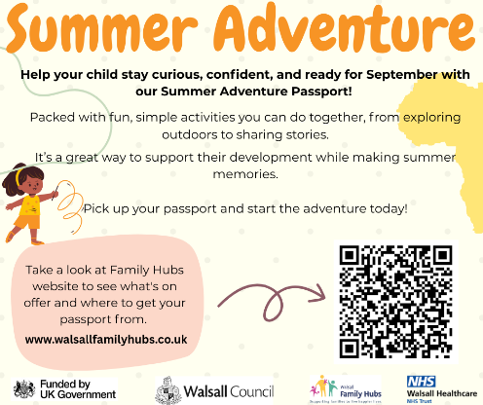
Newsletter
Is your child starting School this September ? We are thrilled to introduce Summer Adventure Passport.
We have lots of fun and exciting activities on offer across Walsall to support you and your little one , while helping them learn new skills throughout the summer.
Take a look at Family Hubs website (Summer Adventure passport :: Walsall Together Family Hub) to see what's on offer and where to get your passport from.

